10.02. Prescription entry
In dispensary mode, supply of items is made using a patient's prescription (rather than a customer invoice for a standard customer in store mode). Choose Patient > New prescription from the menus or the new prescription icon on the Navigator:
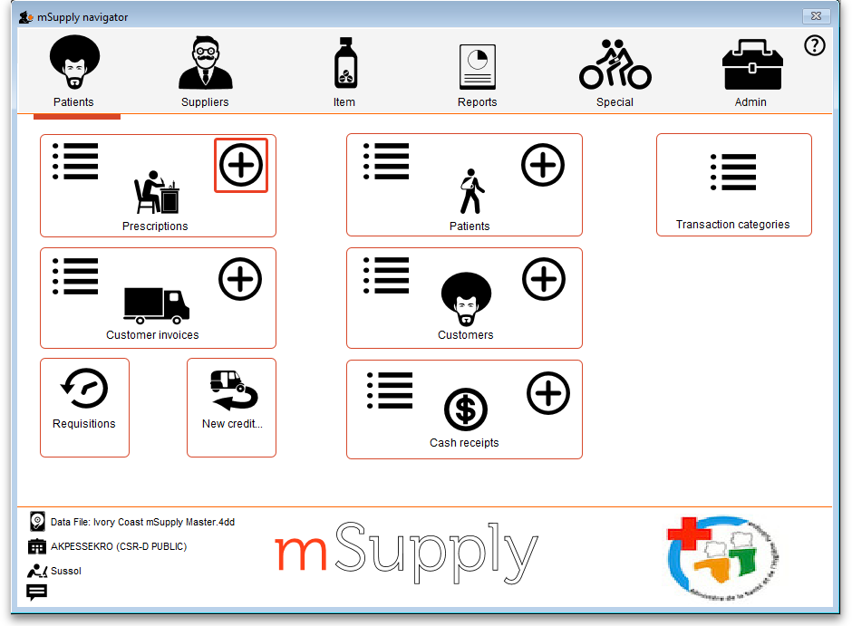
This will show the prescription entry window:
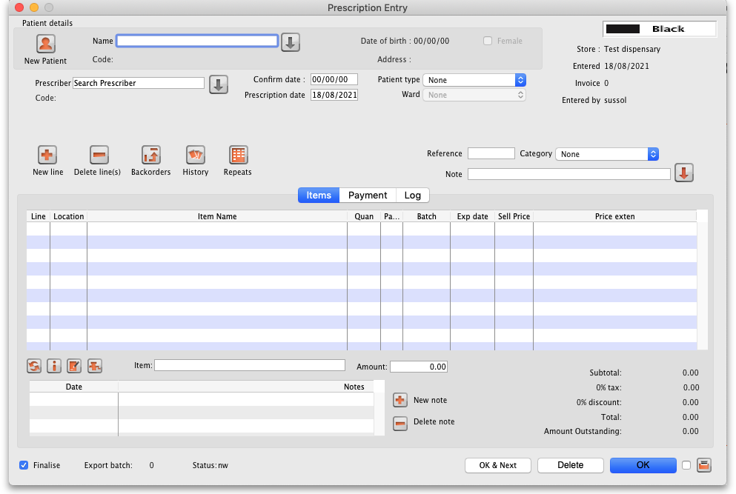

Selecting the patient
Type something in the Name field in the prescription entry window shown above and press the Tab key on the keyboard to see a list of patients matching what you typed.
Anything you type before a comma is treated as the start of a last name, anything typed after a comma is treated as the start of a first name.
- For example, to find John Smith, you could enter “Smi,J” or “smith,joh”
If you know the patient's code, enter the start of it prefixed with an asterisk (*)
- For example, to find the patient with code 5829854 you could enter “*58298”
If your patient has already been created in the system, then these entries should bring up the patient in question, or a small enough list of patients for you to choose from.
Always search for your patient in this way first, before entering a new patient, to avoid entering the same patient multiple times.
If only one patient matches what you have typed, after pressing the Tab key on the keyboard their last and first name will be put in the Name field separated by a comma and their other details will be filled in on the rescription entry window e.g. patient code, date of birth, gender, address.
If more than one patient matches what you have typed, after pressing the Tab key on the keyboard you are shown a list of the patients that matched:
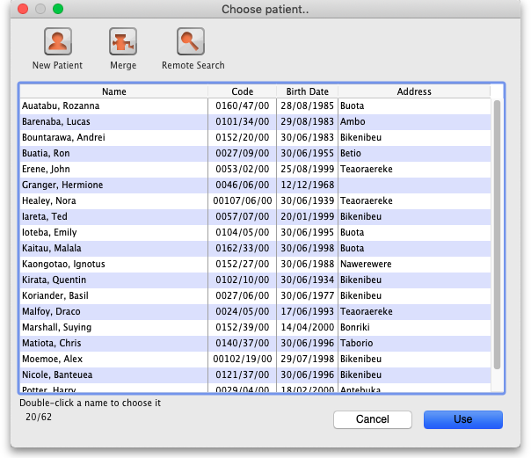
- Find the correct patient in the list and double-click on them or single-click on them and click the Use button to select them.
- If you can't see the correct patient, click on the Cancel button to try the search again or to add them as a new patient as described on the Patients page.
- When you select a patient a few of their details will be displayed in the Patient details section of the window and any Notes they have will be displayed (see here for details on how to update their notes).
The Remote search button is only visible if you are on a remote site in a synchronisation system. If the patient you want is not shown then you can click on the button to inmclude all patients that are not visible in your store to be included in the search. If you select one of those patients they are made visible in your store and their details are downloaded for you.
Please note that if you are on a remote site in a synchronisation system then this window will appear, regardless of whether 0, 1 or more patients match what you typed in the Patient field - this is to ensure you always have the option of doing a remote search for the patient.

Editing patient details
Once you have chosen a patient, you can click the small down-arrow to the right of the patient name to display a window where the patient details can be viewed and edited (see below):
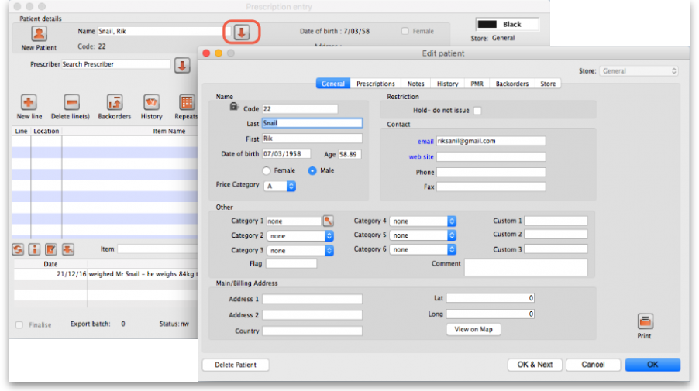
Clicking the Print icon at this point will give you access to reports showing all prescription history.

Entering the prescriber
Once you've chosen a patient, the cursor will automatically advance to the prescriber entry field.
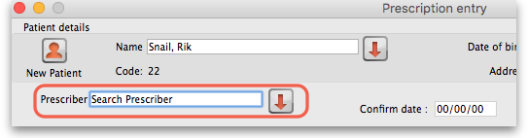
To enter a prescriber, you can type either their code, their last or first name in full or abbreviated, or “last comma first”. For example for the prescriber Dr Felix Brown (whose code is 123) any of the following are acceptable:
- 123
- bro
- fel
- bro,fe
Press the Tab key on the keyboard after making the entry to show a list of matching prescribers. If only one prescriber matches, the name will be entered directly without the list being shown. This is the window that appears to allow you to select the prescriber:
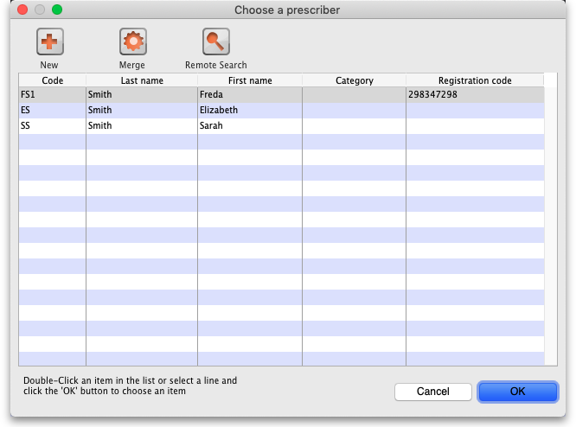
Double-click the prescriber you want or single click it and click on the OK button.
The Remote search button will only be displayed if you are on a remote site in a sync system. Click it to include prescribers that are not visible in your store in the search. Note that if you are on a remote site in a sync system, this window will always be shown when you search for a prescriber, regardless of whether there are 0, 1 or more prescribers that match what you have typed in the Prescriber field so that you always have the chance to do a remote search for a prescriber.

Patient type and ward entry
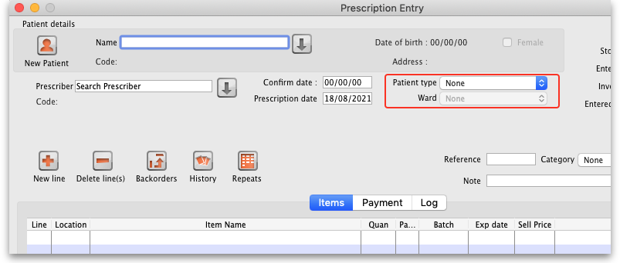
The Patient type and Ward fields only appear if their contents have been setup in mSupply first. See the 10.12. Patient type and Ward setup page for details on setting them up.
When the prescription window first opens, the Ward field will be disabled. It will only be enabled when a Patient type of Inpatient or Discharge is selected. So a ward can only be selected for a patient of Discharge or Inpatient type.

Entering prescribed items
On the Prescription entry window click on the New line button and the Add item window appears:
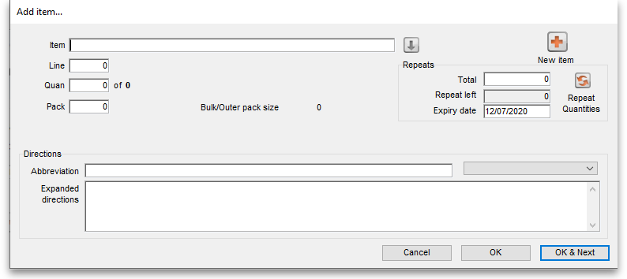
Type the first few characters of the item's name or code in the Item field and press the Tab key on the keyboard to select the right item from a matching list. Tip: if you enter the complete code mSupply will be able to identify the item and will select it straight away, saving you time and mouse-clicks. Another tip is that if the Show item unit column when issuing store preference is turned on (see the 25.08. Virtual stores page for details) then an Item unit column will also be included in the table used to select the items from.
When you have selected the item, the details of the stock available for that item are filled out:
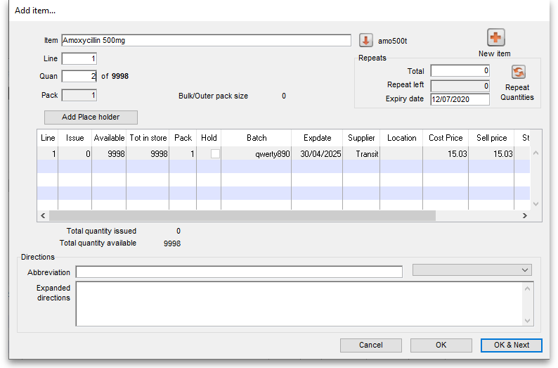
After you have selected the item, if you have told mSupply to inform you of interactions (see the 15.01. General preferences page for details) then an additional Interacting items button will be displayed on this window. Click on it if you wish to see interactions that this item has with other items. If there are any interactions between this item and any dispensed to the patient within the set length of time, you will be shown a warning message.
The first line of stock in the table is selected by default (the first expiring one). If you want to dispense from another, double-click it in the list. Enter the amount you want to give the patient of the selected stock line in the Quan field and click on the OK button if you've finished adding lines or the OK & Next button if you want to add another line.
Note that if the store preference Edit prescribed quantity on prescription is turned on (see Store preferences for details), an additional Prescribed quantity field is present for you to enter the appropriate quantity:
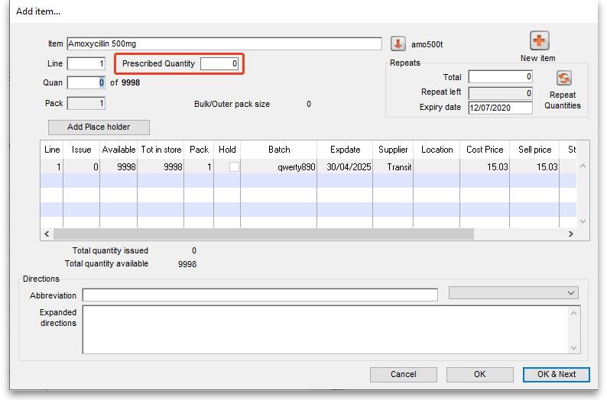
If the Show direction entry in dispensary mode preference in File > Preferences (Dispensary mode tab) is turned on then you can now enter the directions telling the patient how to take the medicine.

Entering directions
For many commonly prescribed items, default direction abbreviations can be defined - refer to the section on Item Default Directions. In the example below, the item being dispensed is FRUSEMIDE 40mg tablets, and the default directions are “Take ONE tablet in the morning”. Alternative directions present may be displayed by clicking on the down arrow to the right of the abbreviated direction field; directions not already present may be typed in using either the Abbrev entry area, or the Expanded entry area.
Note that you can mix abbreviations and text like this.
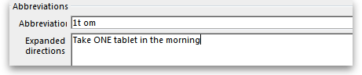
The drop-down list shows any default abbreviations you have entered for the chosen item. If one or more default abbreviations exists, the highest priority default abbreviation will be 'suggested' when you choose the item. If there is more than one standard abbreviation available, you can choose another one by choosing it from the drop-down list.
mSupply stores the expanded text for each line, not the abbreviation. This means that there is a full audit trail of what was printed on the label (unless you edit the directions after printing!).

Default directions
The set up of default directions is done on the dispensing tab when editing an item. You will find it described here.

View history
In the new prescription entry window, once you have entered a patient name you can click the “history” button to view a patient's history of what you have dispensed.
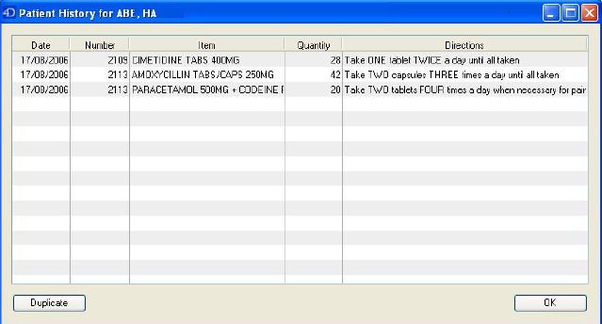

Duplicating a prescription
Once you have a history window open you can click to select a single entry or control-click to select multiple entries, then click the “duplicate” button to create new prescription line(s) with exactly the same details. Stock will be issued for these lines automatically.

Repeats
mSupply allows for the recording of repeat prescriptions. This is achieved when the prescription is first dispensed; in the Add item window, click on Total field in Repeats box in the top right corner of the window, and enter the number of repeats that the prescriber has authorised. The Repeat Dispensing procedure is described below.
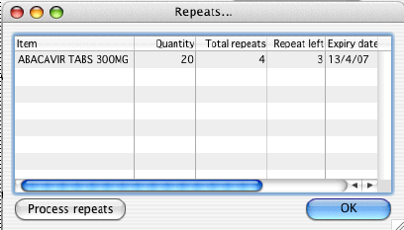

Repeat dispensing
The Repeats panel (upper right of the window shown below) allows details of repeat prescriptions to be recorded. Take the example of a patient presenting a precription for Frusemide 40mg tabs x 30 on 1st January 2007, with the prescriber requesting “Repeat monthly x5”; in the Total field you should enter “5”, and in the Expiry Date field you have the option of entering (a) the actual date on which the final repeat may be issued - in this example, “1 July 2007” (allowing the patient one month's grace) - or (b) “6m” for 6 months. Note that the characters “D”,“W” & “M” in upper or lower case are interpreted in this particular field as the specified number of days, weeks or months before the repeat instruction expires. mSupply defaults to an expiry date two months later than the current date, but this may be edited as appropriate. The system automatically updates the number of repeats remaining as the patient makes further visits to have the repeats dispensed. The window below is displayed when you click on the New line in “ Prescription window ”
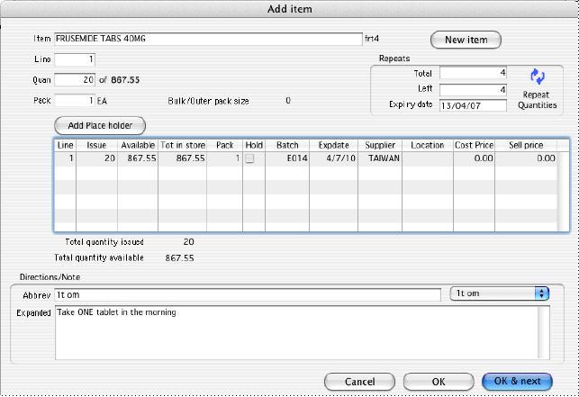
The number of repeats is assigned in Total field in Repeats box, and as the repeats are dispensed, the number remaining is displayed in the Left field.
When you click on the blue arrows on the upper right side ,the total repeat number and total quantity for each repeat is shown. Clicking on the small arrow displays the window below.
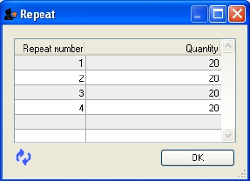
This window allows the user to alter the quantity of a particular repeat - e.g. if there is insufficient stock on a particular visit of the patient; the quantity can be edited by clicking on the quantity line, and again clicking on the quantity, which may now be edited. The arrow on the left bottom corner enables you to restore the default quantity setting.
Once you have filled repeat and other details on the Add item window properly, click on OK button to save details.
The Repeats icon is contained in Prescription entry.
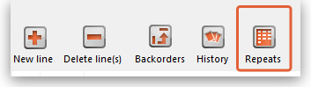
When the Repeat function is used, and there are future repeats to be issued, the icon appears on a red background:
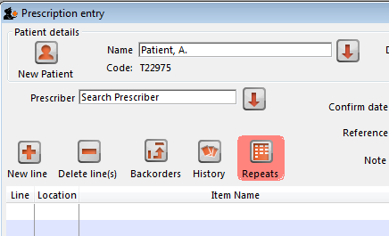
The red background disappears when either:
- expiry date is reached
- all repeats have been dispensed
You can issue the repeat to a particular patient. Clicking on the Repeats icon displays this window:
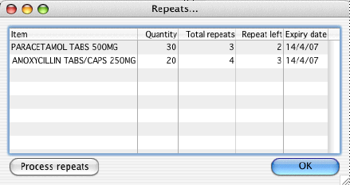
The repeat window shows items to be dispensed, quantity, total repeats, repeats remaining and expiry date for a particular repeat.
- Process repeats button: This button is used to issue the repeat for a particular patient and for a particular item line. For issuing the repeat, first select a desired item line and then click on the Process repeats button. Now the system automatically manages the repeats internally.
- OK button: Click the OK button to exit from the Repeats window.
There is an Alert if repeat is dispensed before the defined interval of X days preference you can set to ask the user to donfirm if they wish to proceded if a repeat is issued within a selected number of days of confirmation of the original prescription. See the 15.01. General preferences page for details.

Printing labels
Dispensing labels are printed when the Print labels box is checked in the Prescription Entry window. You can specify what information gets printed on dispensing labels in Dispensary Mode Preferences.
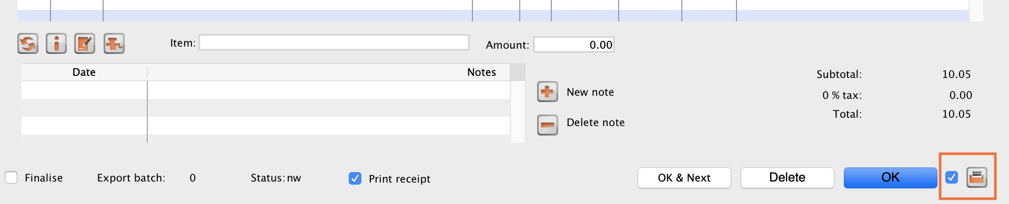
Sample labels, produced by the Zebra TLP2844 printer are reproduced below:
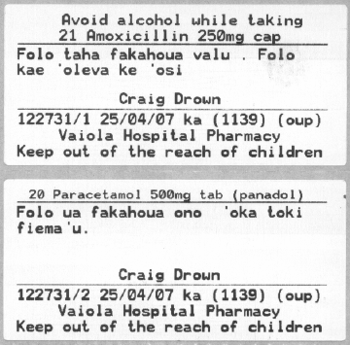
mSupply currently is designed to work with the Zebra TLP 2844 label printer. The Zebra is a very nice printer. It can use either thermal labels or a thermal ribbon which gives non-fading results.
We currently support plain 90 x 40mm label stock as this is cheap and readily available. The Zebra printer is auto-sensing of the ending of a label, so you can most likely used labels longer than 40mm with no problems.
- Label specifications:
- 90mm x 40mm high
- White Matt Thermal Transfer Paper
- Wide Edge Leading
- 1 Across on a roll
- Perforation between each label
- Produced on 1“ core to suit TLP2844
We are happy to support other printers if you use a different brand.

Reprinting labels
If you need to print the labels for an item again, choose Patient > Show Prescriptions to locate the prescription entry.
In the list of items dispensed, click on the line you wish to reprint, and then click OK (with the printing checkbox checked)
If you wish to reprint labels for all the items on the prescription, first click in the list of items below the last item so that now one item is highlighted. Then all labels will be preinted when you click OK

Printing multiple labels
If you want to print more that one label for an item, hold down the Alt key ( Option on Mac) as you click the OK button. You will be asked for the number of labels required as the label is about to print.

What if there is not sufficient stock of one batch?
As the quantity of a particular batch of an item gets used up, you will need to issue stock from more than one batch to a patient. mSupply handles this when printing labels, and combines the totals for any item on a prescription so that only one label is printed for the total quantity.
The directions for the item with the first line number will be used, so enter directions for the first batch you dispense, and leave the directions empty for subsequent batches.
Note: if you have the rare situation where you need to issue the same item to one patient with different directions you should either combine the directions onto the one label, or enter two prescriptions with the directions entered differently on each prescription (That is enter the line, then print the label(s), then choose Patient > New prescription and issue the item again with the second set of directions).

Receiving payments
You can recieve payments for prescriptions directly from the prescription window if you wish (an alternative is to receive them using the customer receipts module. Both result in the same transactions being created in mSupply but will suit different physical workflows).
See the special page on receiving payments from the prescription window here 11.03. Prescription payments and credits.

Printing receipts
You can print a receipt for a patient's payment of a prescription if you have the Receive payments from prescription window preference turned on (see Dispensary preferences for details) .
Receipts are printed (from the same printer as the labels) when the Print receipt box is checked on the Payment tab of the prescription entry window:
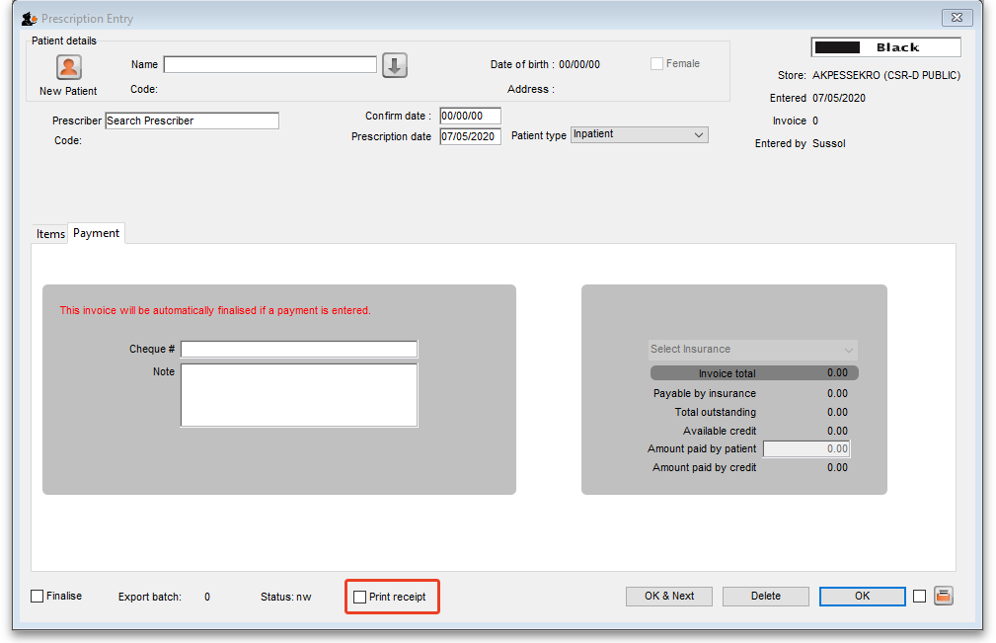
Receipts may also be reprinted later by opening the prescription and checking the Print receipt box again - in which case they will have the text “COPY” printed at the bottom.
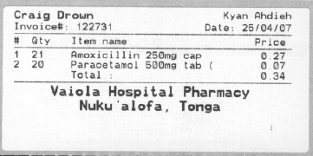
After printing the medicine labels, a patient receipt will be printed as shown below.
If you don't have a printer setup in Special > Printing preferences you will be prompted to select one or set one up. If that is not possible, receipt printing will be cancelled.

Prescriptions and barcode scanners
It is possible to print barcodes on prescription labels and use barcode scanners to open the prescription quickly. For details, please see the 15.07. Barcode scanning and prescriptions page.

Previous: 10.01. Dispensary mode | | Next: 10.03. Patients

