Why is my stock on hold?
180320 This page is under review
Stock can be On hold, and therefore cannot be issued by mSupply, for a number of reasons:
- The Item is On hold
- The Stock line is On hold
- The Location is On hold

Location
Setting the location On hold will prevent any stock from being issued from that location. This is particularly useful if:
- The stock needs to be kept from being issued until some inspection / approval.
- The stock is a bulk quantity with the same expiry date as another stock line, and you want mSupply to suggest issuing from the other stock line.
If you want to make the stock in an On hold location available for issue, then there are two options:
Move the stock in that location to another location that is not On hold Remove the On hold status of the location Steps:
- Find the Location of the Item on Hold
- Items>Show Locations>Search the location
- Double Click on the searched Location
- Uncheck the Hold button.
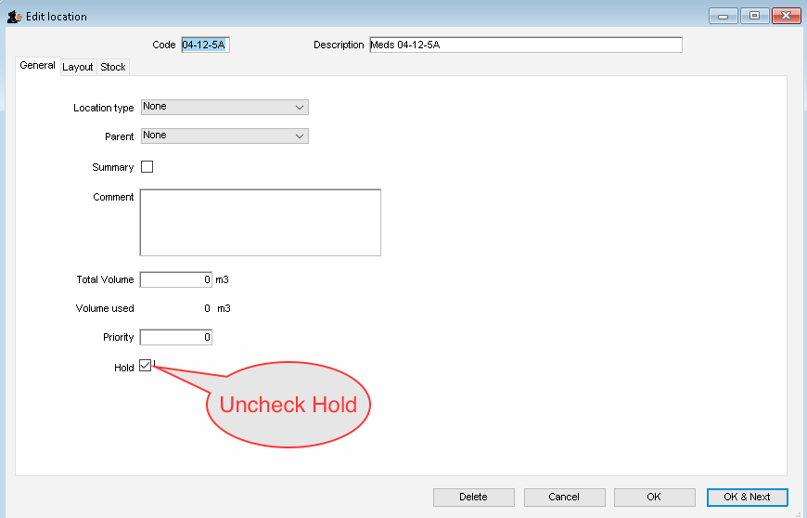Uncheck Hold

