5.02. Contacts
This command from the Special menu displays a window where you can edit contacts.
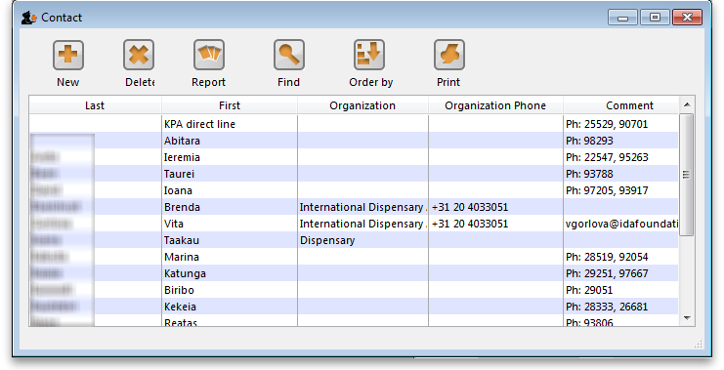
Contacts are usually associated with a name (a customer or supplier), and it is easier to edit such contacts using the “show suppliers…” or “show customers…” command.
If a contact is not associated with a name, you can edit details for that contact using this command.

Buttons in the contact list window
New: Use to add a new contact.
Report: Presents the Quick report editor window. See Using the Query Search editor
Find: Use to find an individual contact
Order by: sort the contacts
Print: clicking this button will present you with a dialog with two choices:
- If you click list a list will be printed of the records in the window.
- If you choose labels, you will be shown the label editor, allowing you to print a set of address labels for the current list of contacts. Note that you can save a particular label layout and then use the load command in the label editor to restore your layout.
New: To edit a contact, double-click on the line you want to edit. You will be shown the contact details:
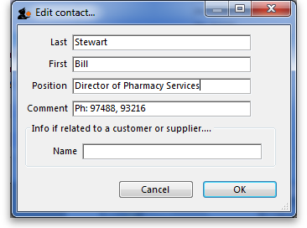
Previous: 5.01. Names: Using, adding and editing | | Next: 5.03. Merging two names

