5.03. Merging two names
If you accidentally enter two names into mSupply that identify the same organisation, you can use this command to combine them.
Use extreme caution: This operation will move all historical records from the name you delete to the name you are keeping. The operation can only be undone by reverting to a backup copy of your data file (so it is a very good idea to take a backup just before you begin any merging).
Access the function by selecting Customer > Merge two names… or Supplier > Merge two names… from the menus.
After selecting one of the options, the following window is displayed:
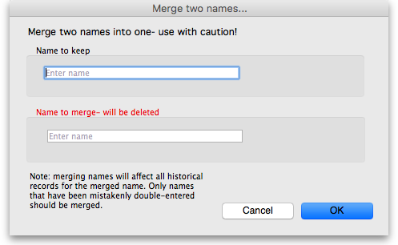
Enter the name to keep (type the first few characters of the name and press the Tab key to select it from a list of names that begin with what you typed), and then the name to merge (same way). When you have checked then checked again that the information is correct, click the OK button. You will be given one last chance to confirm and then the merge is carried out.
The merge takes all instances of the name to merge in the mSupply datafile, wherever it may appear, and replaces it with the name to keep and then deletes the name to merge.
You can also access this functionality by selecting two names from a list of customers or suppliers and clicking on the Merge button at the top:
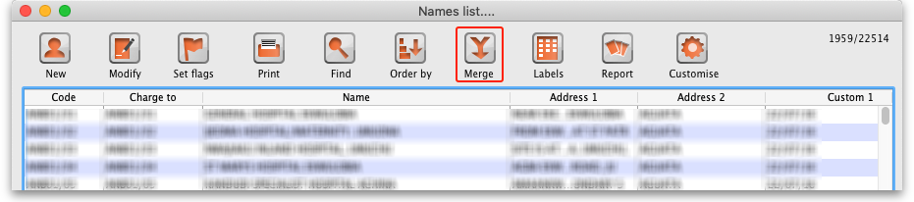
If you do this you are presented with a different window, where you select which of the two names is the one to keep (in green) and which is the one to merge (in red):
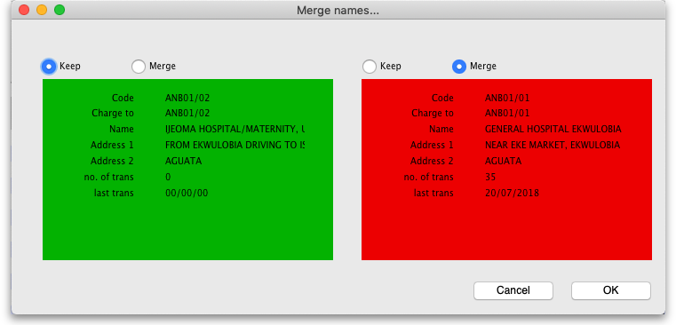
Use the pairs of Keep and Merge radio buttons to select which name is to be kept and which one is to be merged. Make sure you select the right way round then click on the OK button and, after a final confirmaiton from you, the merge will be carried out.
You can also merge a name into a virtual store (the store must be the name to keep). This is particularly useful if, for example, you have a customer which you now want to turn into a store to manage their stock more fully. This has the benefit of moving all the transactions connected with the customer into the store so that you don't lose any historical transaction information.
When you merge a (customer) name with a virtual store you must finalise all transactions belonging to the customer first (mSupply will tell you to do this if you have not already).
In a synchronising system, The merging needs to take place on the primary server, even if the virtual store is 'Active' on a satellite server (see Remote Synchronisation)

Previous: 5.02. Contacts | | Next: 5.04. Name categories

