7.2. Managing purchase orders
Managing purchase orders you have placed is an important part of running a medical supply facility. There are two main windows you will use to do this, along with a variety of reports.

Show outstanding Purchase Order lines....
Choosing this Suppliers > Show outstanding purchase orders from the menus or the Navigator displays a list of all lines outstanding on all confirmed Purchase Orders.

Using the find box
In the toolbar there is a field to enter searches. To the left of the field you can choose from the drop down list what to search for.
You can restrict the list displayed to a single supplier, to a single item, or to items whose delivery is expected within a specific number of days.
This search excludes finalised orders.

Printing and opening in Excel
Click the Print button to print the list as displayed. If you want to send the list to Excel, choose Open in Excel from the print options window that is shown after you click Print Double click on a line to display the Purchase Order containing that line
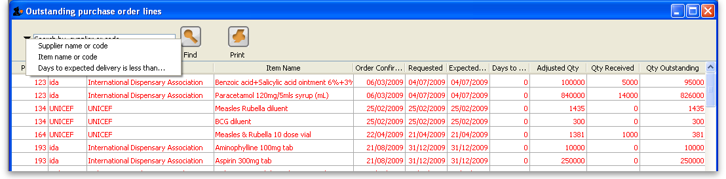

Show Purchase orders
Choose Suppliers > Show Purchase Orders.
- In the find window you can choose what will be displayed. By default mSupply displays the last 15 purchase orders.
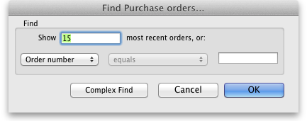
- You will be shown a list of matching Purchase Orders. Double-click a purchase order to open it.
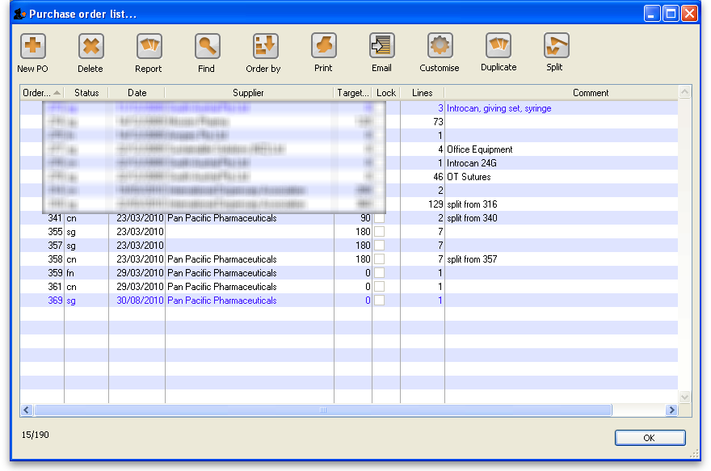
For a more detailed description of this window see Ordering Items From Suppliers
Previous: 7.1. Ordering Items From Suppliers | | Next: 7.3. Purchase Order categories

