3.07 Viewing location in Google maps
If the precise geographical location of the supplier or customer is known, the Lat and Long fields can be completed in the Photo tab. Entries are made in these fields thus:
- decimal degrees, and not degrees, minutes and seconds
- in the Lat field, locations south of the Equator are entered as negative - i.e. the number is preceded by a '-' sign
- in the Long field, locations west of the Prime meridian are entered as negative - i.e. the number is preceded by a '-' sign
Don't know a precise location? Using Google Maps find the desired location and place the cursor on it. Right click and select What's here from the drop down list. The geographical co-ordinates are displayed at the top of the screen. These should be noted and copied to the appropriate Lat and Long fields in mSupply®
In our example, the location of the imaginary Acme Pharmaceuticals is on Chetrapati in Kathmandu. Click on the Google Maps button to display a map of the vicinity, with the precise location pinpointed by a green arrow.
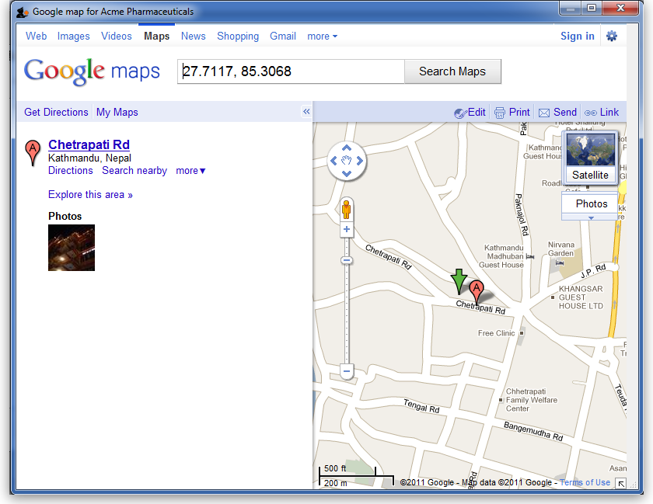

Previous: 3.1. Logging in | | Next: 3.3. Working with lists

