20.04. Fridgetags Itegration
As of version 6.03 mSupply now integrates with Berlinger Fridgetag 2s
(More details here when v6.03 is released)

Setting up sensors
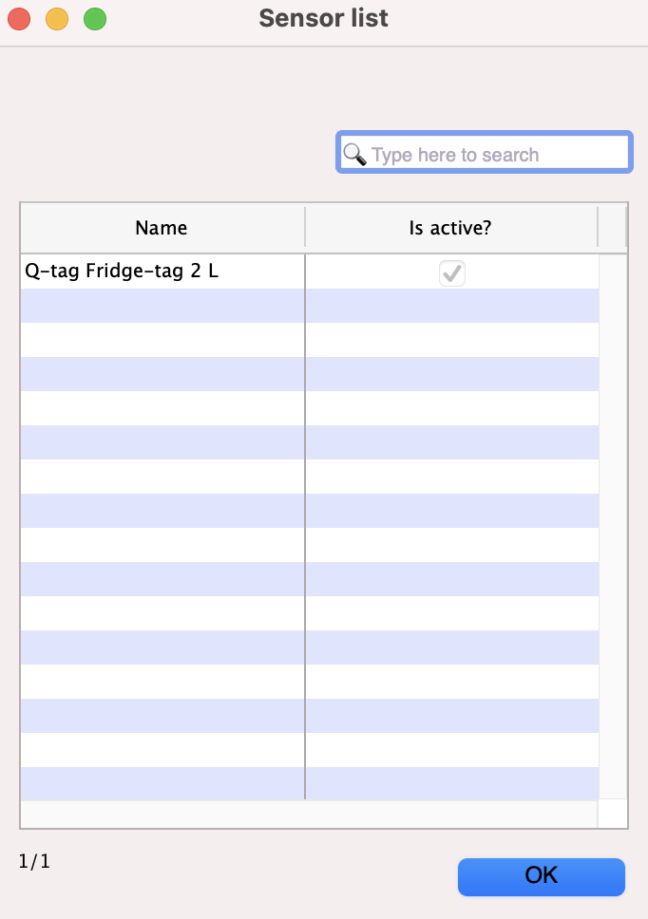

Locations
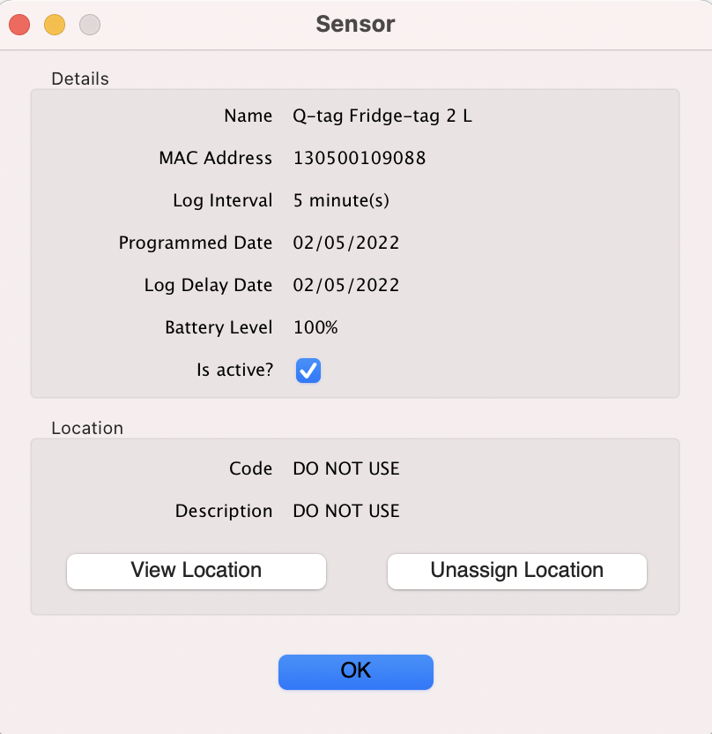

Viewing logs


