Why is my stock on hold
Stock can be placed on hold a number of ways.

Location
Setting the location on hold can disable the stored stock from being distributed. Steps:
- Find the Location of the Item on Hold
- Items>Show Locations>Search the location
- Double Click on the searched Location
- Uncheck the Hold button.
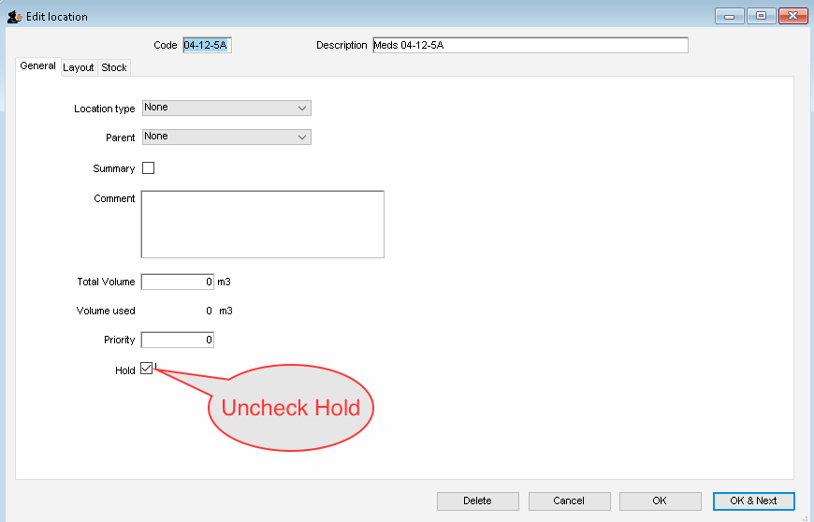Uncheck Hold

