20.04. Procedures
Internally, a procedure in HIS is treated like a service item in mSupply, so many of the same concepts apply - see Items
The Special > Show procedures menu item allows you to track surgical and other procedures performed on patients. It brings up the following window:
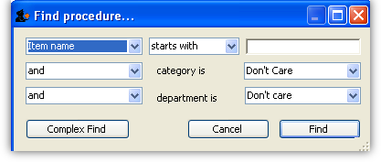
After setting the parameters, and clicking on OK, it will either show the list of procedures:
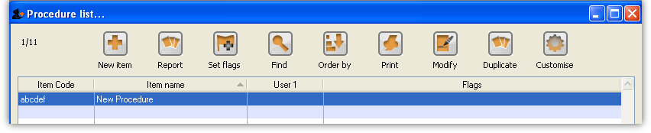
in which case, you can double-click on a procedure to view/edit it or select New item to create a new one. Or, if there are no existing procedures, it will go straight to the Add procedure window:
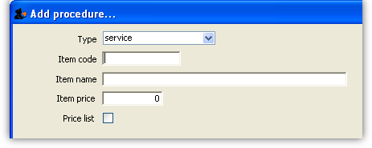
The type of a procedure is fixed as “service”. As for items, once a procedure has been added, there are extra fields and tabs available. However, only a subset of the normal item fields are available.
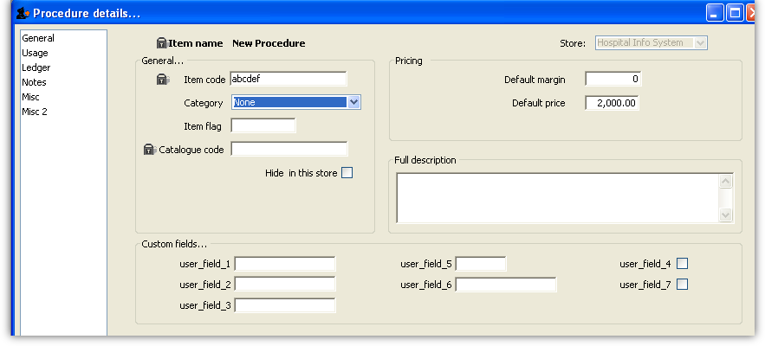

Previous: 20.03. ICD disease codes | | Next: 20.05. Patients

