17.05. Importing abbreviations
Importing abbreviations is a great way of quickly entering a large number of abbreviations for use in dispensary mode (see the Abbreviations section for details).
To create the import file, create a spreadsheet with two columns like this:
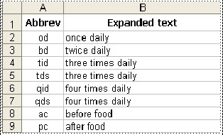
Enter the short abbreviation you will type in the Abbreviation column. Enter the text this will be expanded to in the Expanded text column. Make a new row for each abbreviation.
Note: your abbreviations cannot contain the underscore (_), period (.) or comma (,) characters.
If there are any non-printable characters or spaces in the abbreviations they will be removed on import.
When the spreadsheet is complete, export it as a tab delimited text file.
Close the spreadsheet application then choose File > Import > Import abbreviations… from the menus in mSupply. Select the file you just created in the window that opens (navigate to it and either double-click it or single-click on it and click on the Open button). The following import options window will be displayed:
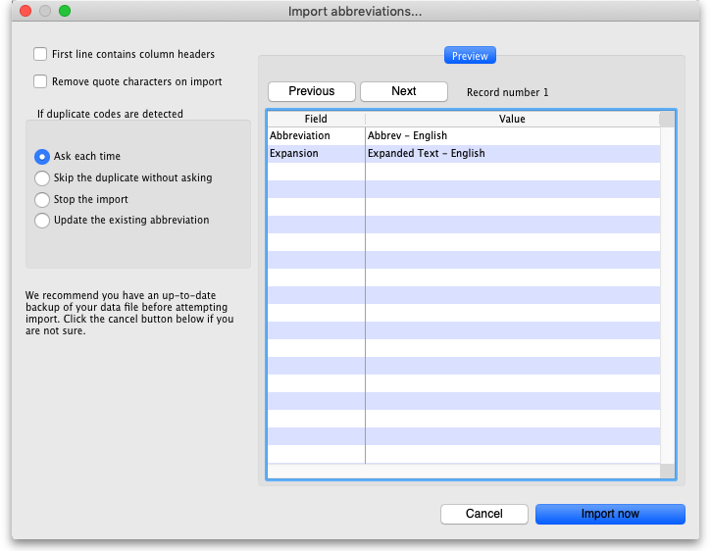
If the first row in your spreadsheet contained the column headers and not an abbreviation, check the First line contains column headers checkbox to tell mSupply to ignore it.
If the spreadsheet software has added quotes around any of the fields during the export to a text delimited file then check the Remove quote characters on import checkbox (you can use the Previous and Next buttons in the preview panel to see if quote characters have been added).
Select one of the options in the If duplicate codes are detected section to tell mSupply what it should do if an abbreviation already in mSupply or previously in the spreadsheet is detected.
When you're ready, click on the Import now button to carry out the import.

Previous: 17.04. Importing prescribers | | Next: 17.06. Importing customer budgets

