15.04. Importing prescribers
Applicable in Dispensary mode only
From the File menu, choose Import Prescribers, and the Import alert window is displayed.

You may import a list of prescribers who have the authority to prescribe medicines.
Your list should be in the format of a 6-column spreadsheet, saved as a tab delimited file. The columns should be in the following order: <HTML>
</HTML>
Column 1 | Unique code for each prescriber
Column 2 | Last name
Column 3 | First name
Column 4 | Initials - these will appear on patient labels
Column 5 | Registration code
Column 6 | Category
<HTML>
</HTML>
Your tab delimited spreadsheet file would appear something like this:
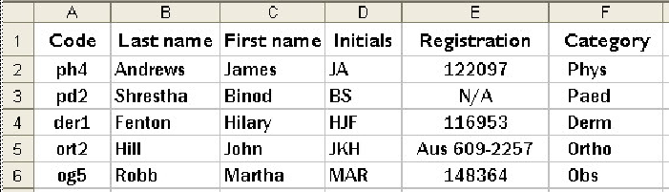
Choose import options from the preview window and click OK to begin import.
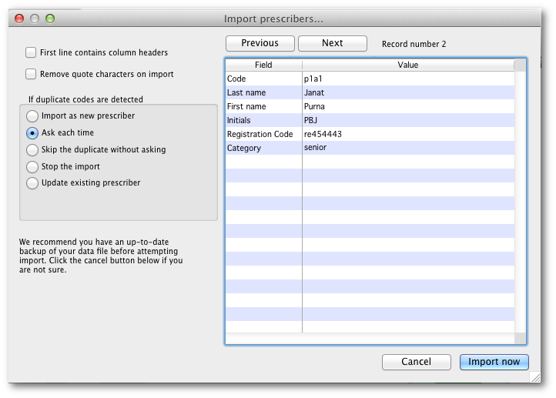

Previous: 15.03. Importing names (customers, suppliers, manufacturers, patients) | | Next: 15.05. Importing abbreviations

