4.01.08. Items - Backorders tab
Back to Item Details window
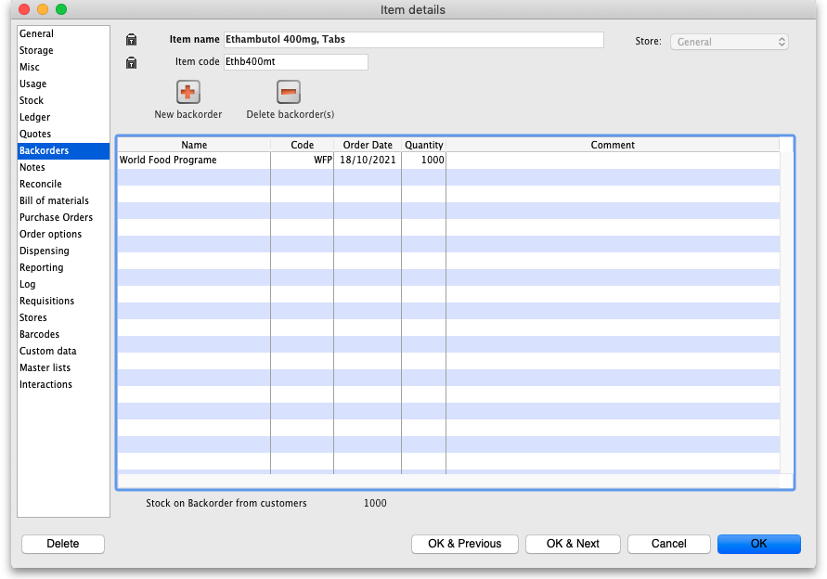
You can view the backorders for an item here. To edit a backorder, double-click the line you wish to edit.
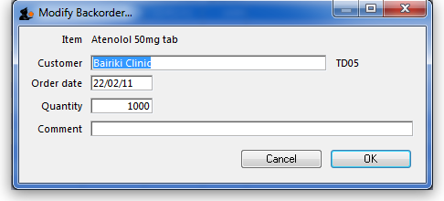
To add a new backorder for this item, click the New backorder button. This window will be shown:
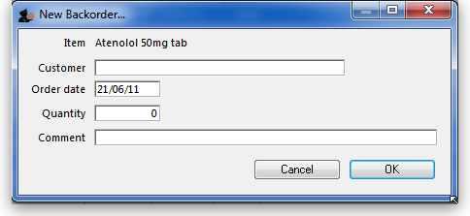
- Enter part of the customer name, then press Tab to search for the customer.
- Enter the order date, quantity and any comment, then click OK to save the new backorder entry.
To delete a backorder, select the line you wish to delete by clicking on it, then click the Delete backorder(s) button. You can also select several at once (using ctrl/cmd+click and shift+click) or all the backorders in the list using ctrl/cmd+a and delete them at once.
The total stock on backorder is shown below the list.
Previous: 4.01.07. Items - Quotes tab | | Next: 4.01.09. Items - Notes tab

