4.01.22. Items - Interactions tab
Back to Item Details window
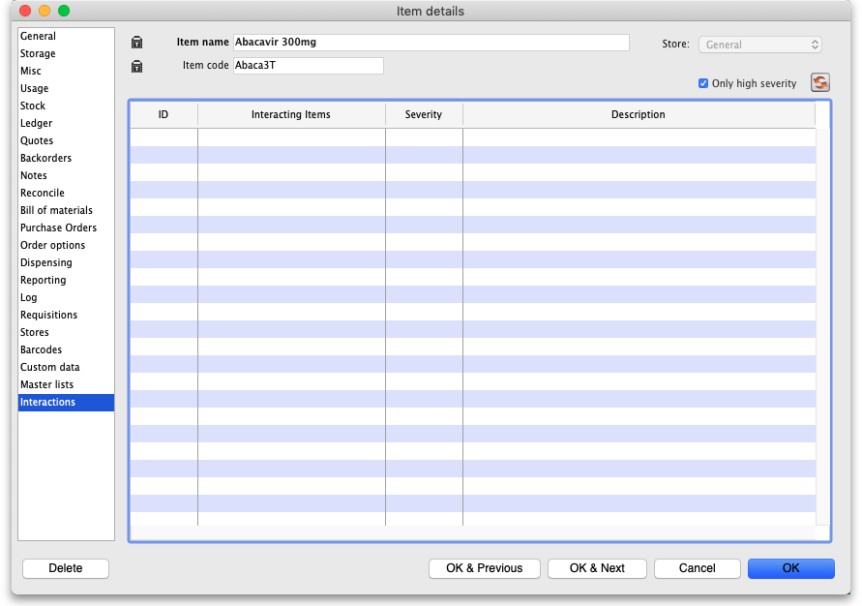
This tab is read only and displays the interactions this item has with other items. These interactions are automatically downloaded from the universal code server (https://codes.msupply.foundation/) when a universal code has been applied to the item. See the 4.01.01. Items - General tab page for details on how to assign a universal code to your items.
By default only the high severity interactions are downloaded from the universal code server. If you need to refresh the interactions (for example if there have been new ones added to the universal code server) then click on the button. This will remove all interactions, re-download them from the universal code server and show them in the table.
If you want all the interactions for this item then uncheck the Only high severity checkbox before clicking on the on the button (beware - there could be a lot of interactions if you uncheck this checkbox and it could take a while to download them all if your internet connection is not very fast.
For details on how interactions are used in mSupply see the 4.11. Managing drug interaction groups page.
Previous: 4.01.21. Items - Master lists tab | | Next: 4.02. Adding a new item

