4.01.07. Items - Quotes tab
Back to Item Details window
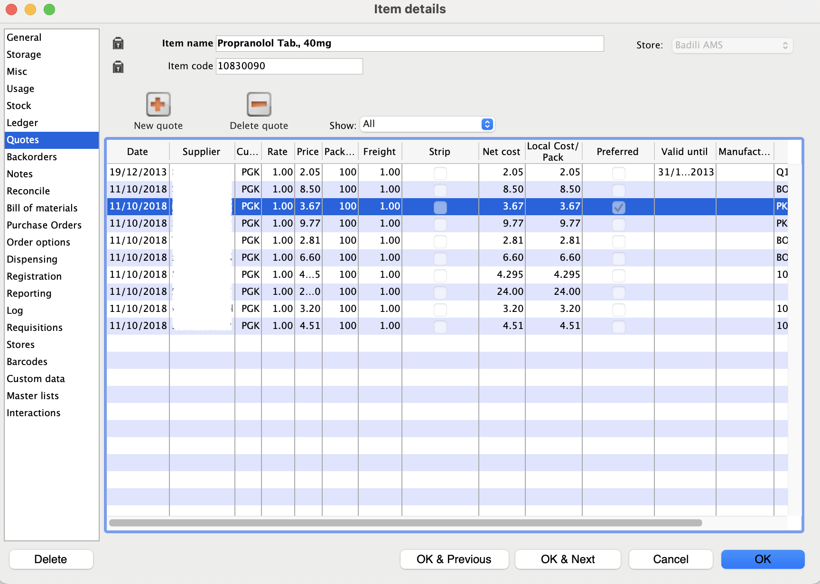
A quotation is a record of a price you have been given by a supplier. For each item you can have multiple quotes recorded, reflecting different prices you have been quoted from different suppliers, or even different prices from the one supplier for different pack sizes.
When you come to compare quotes, there are several factors that need to be taken into account. By entering the information in mSupply® you are able to find the best price once these factors have been taken into account, and you build a history of quotations from each supplier.
The date until which the quote is valid is displayed, and you can choose to display all quotes, or currently valid quotes.
There may be occasions when a supplier has quoted for an item from two or more manufacturers, and in such cases, the manufacturer's name will appear in the column headed Manufacturer .
Cost: Cost is the price for that pack size in your local currency, taking into account the freight factor and the exchange rate.
Adjusted cost: Adjusted cost is the price for your “preferred pack size” you have entered for that item. This second price allows for a direct comparison between suppliers. Note that if you change the “preferred pack” for an item, all your quotes will be updated to reflect the new pack size.
Comparing quotes:: Click “Adj cost” heading in the list of quotes to bring the cheapest quote to the top of the list.

Add a new quote
Click the “new quote” button. The quotes input window will open
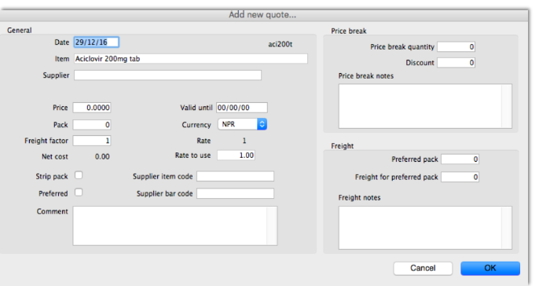
- Type as much of the supplier code as you know, then press the Tab key- you will be presented with a list of suppliers if there is more than one to choose from.
- Enter the price and the pack size in the currency you have been quoted.
- Note that the currency and freight factor are filled in with the information you have entered for the supplier.
- If the supplier has quoted in a different currency to the supplier's default currency, you can change the currency for this quotation from the drop-down list on the right.
- The freight factor is the factor you need to add to the supplier's prices to account for delivery costs. If your supplier includes these costs in the quoted price (i.e. prices are “CIF”), the freight factor for the supplier should be set to “1”. If your supplier adds freight that amounts to about 15% of the invoice price, set the freight factor to 1.15.
Strip pack: This check box allows easy identification of quotes that are for strip/blister packed items (as opposed to “loose” items).
Preferred: This check box allows you to identify one supplier as the preferred supplier for the item. One of the ordering methods uses the “preferred” check box to indicate which items should be considered for ordering from a particular supplier. See Ordering from suppliers for more details.
Supplier code: If you are using electronic invoice transfer, you must use this field to record the code for the item that this supplier uses on their electronic invoices.
Supplier bar code: Here you can record the bar code identifier for this product.
Price Break: Enter the quantity that generates a price break along with the percentage discount that will apply once this quantity is reached.
Freight: Enter the value for the preferred pack (outer pack) and the freight for that pack provided by the supplier.
Click OK to accept the details, or cancel if you decide not to add a quote for this item.

To modify a quote:
Double-click the line you want to edit.
In the window that appears you can change the date, the supplier, the price, the pack size, the Strip check box, or the Preferred check box.
To delete a quote:
- Click on the quote line you wish to delete
- Click the Delete quote button
- Confirm that you want to proceed
Previous: 4.01.06. Items - Ledger tab | | Next: 4.01.08. Items - Backorders tab

