4.01.17. Items - Requisitions tab
Back to Item Details window
The Requisitions tab shows the stocktakes featuring this item,
- Choose a date range from the drop-down list to show custom stocktakes within that range.
- Double-click a row to view the customer stocktake in question.
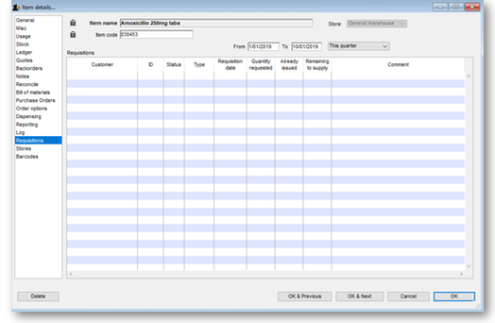

Previous: 4.01.16. Items - Log tab | | Next: 4.01.18. Items - Stores tab

