Merging two items
If an item has inadvertently been added twice, with slightly different descriptions, here is your safety line! Choose Merge two items… from the Item menu. Enter the item to keep and the item to be merged.
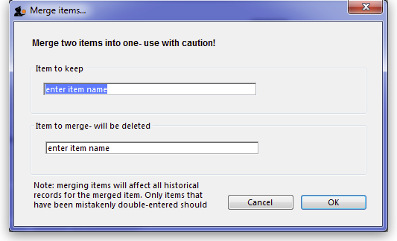
If you merge two items that are, in fact, different, you will really mess things up. There is no un-do for this operation, so you will be begging us to help you fix the mess, and we charge a special penal rate for people who do things after having been warned
- Notes
  - Merging items affects all historical records except for item names on finalised transactions, which will retain the original name for safety reasons.
  - Items that either have a bill of materials or are used in a bill of materials cannot be used for the item to delete/merge. If you try to do so, you will be warned.
  - If the item you are merging/deleting has stocktake lines associated with it, these stocktake lines will be deleted, as you can't stocktake a non-existent item (except if you're Harry Potter).
Previous: Building (Manufacturing) Items Next: Ad hoc items

