Splitting a stock line
The Split feature of mSupply provides us with the ability to break down stock into smaller pack sizes, consolidate it into larger pack sizes or move part or all of a stock line to a new location. Here's how to use it:
- From the Item menu choose Show items to find the item to be split
- Enter the start of the item name and click Find
- Once the Item details window is displayed, choose Stock from the side bar list and you will see this window:
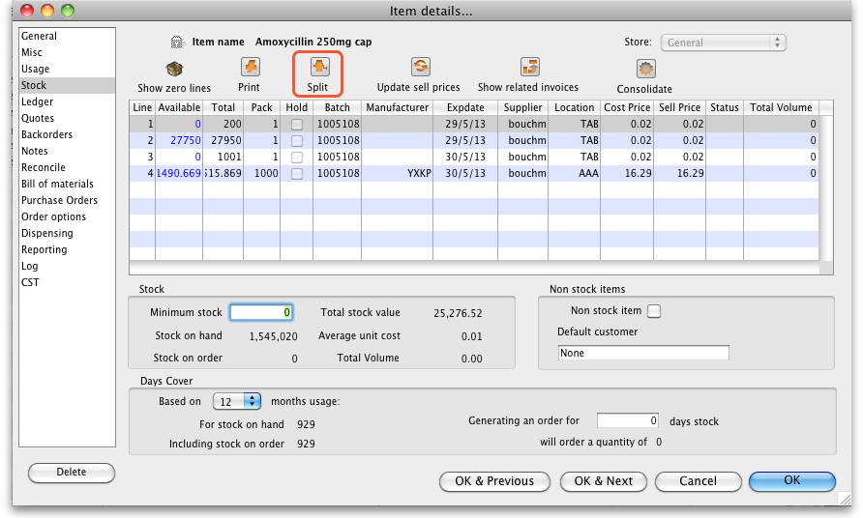
- Click on the line you want to split, then click Split:
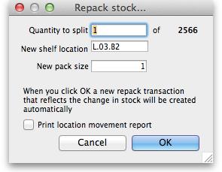
- In the Quantity to split field enter the number of packs you want to move/split (if you're repacking the whole lot, then enter the total quantity - the number to the right of the word 'of'!)
- In New location enter the new location for the packs that are being split (leave it alone if you're not changing the location)
- In the New pack size field enter the The new pack size for the split items (leave this as it is if you're not changing the pack size!).
- Click OK and you're done - the changes will be immediately visible in the item stock details window.
So, to summarise, you can use the split command to perform these actions:
- Change the location of some or all of a stock line
- Repack some of a stock line into a different pack size
- Both of the above at the same time!

Produce a Movement report
mSupply provides a feature to produce a 'Movement report' for stock that you have moved to a different location using the split function. It's useful for printing off and giving to the person who is going to physically move the stock in the store.
Here's how to create one:
- Once you have entered the details of your split/new stock location, click on the checkbox labelled Print Location Movement report and click OK:
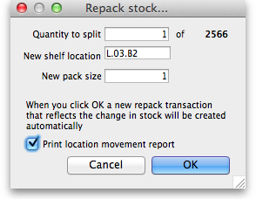
- The following report is displayed:
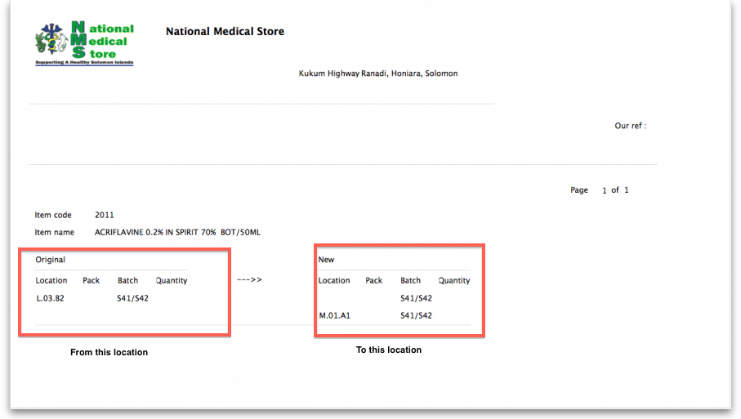
- Note that the original and new locations are clearly identified so a printed version of this report can be easily referred to when physically carrying out the move in the warehouse.
Previous: Show items with stock Next: Stocktakes

