Name Categories
*
You can categorise names in mSupply with 6 different categories. You can apply 1 or all or some of these categories to a name. Categories 2-6 are standard categories but category 1 is special - it's hierarchical and has 3 levels, level 1 is the top and level 3 is the bottom (similar to item categories).
Suppliers and customers have their own sets of categories. To view and edit them you choose Show categories from the Customer or Supplier menu and that brings up this window:
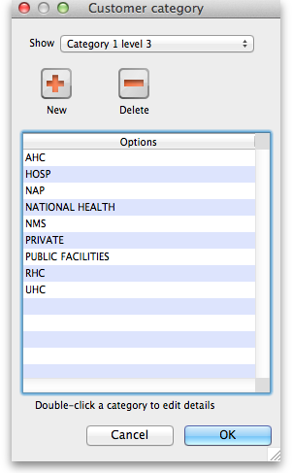
Here you can add and edit categories for your suppliers or, in this case, your customers.
Show drop down list: This determines which category type is shown in the list and which type of category will be created if you click on the New button.
Delete button: Deletes the category you have selected in the list. You'll be asked to confirm the deletion first of course!
New button: Opens up the new category window which looks like this (Note that double clicking on a category in the list opens up this widow too but it will be populated with the current settings for the category you double clicked so that you can edit them all):
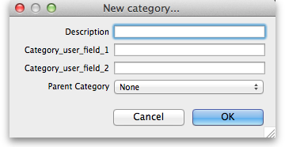
Description:
Category_user_field_1:
Category_user_field_2:
Parent category drop down list: This doesn't appear if you're editing or creating a non-hierarchical category 2-6.
Previous: [[items:ad_hoc_items|Ad Hoc items]] Next: Suppliers: Adding and Viewing

