26.20. Document registry
The document registry is for storing…something very mysterious for Open mSupply. We will divulge the secret soon…

View the current stored documents
To see a list of the currently stored documents, choose Special>Show document registry… from the menus. This window will open:
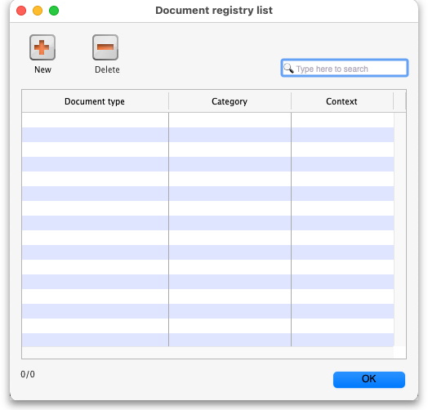
This shows a list of all the documents currently stored. If the list is long and you want to find a particular document then type something in the Type here to search field and the list will show only those documents with what you typed in their Document type.
The number in the bottom left of the window is in the format x/y where x is the number of documents displayed in the table and y is how many documents are stored altogether (i.e. displayed when nothing is entered in the Type here to search field.

Deleting a document
Select a document in the list by clicking on it and click on the Delete button. After confirmation the document will be deleted and will no longer be available for use.

Adding a document
Click on the New button and this window will open:
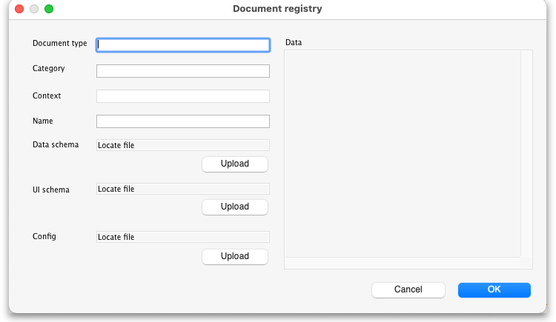
- Document type:
- Category:
- Context:
- Name:
- Data schema:
- UI schema:
- Config:
- Data field:

Editing a document
Double-click on the document you want to edit in the table and the same window for adding a new document will open but populated with the selected document's details. Edit any of the details as required then click on the OK button to save your changes. Click on the Cancel button to discard your changes.

Previous: 26.19. Migrating to Open mSupply | | Next: 27. Help

