16.09. Barcode scanning preferences
- The preferences described here (accessed through File > Preferences…) apply to all stores on an mSupply server.
- In a synced system there will be multiple 'sync satellites' and these settings can be different on each sync satellite.
- There are some settings that are 'per store' - refer Store preferences, and store preferences can be different for each store on an mSupply server.
If you want to use barcode scanners in mSupply, this is where you set up the preferences for communicating with your barcode scanner.
Note: Only a single barcode scanner can be connected to a computer running mSupply
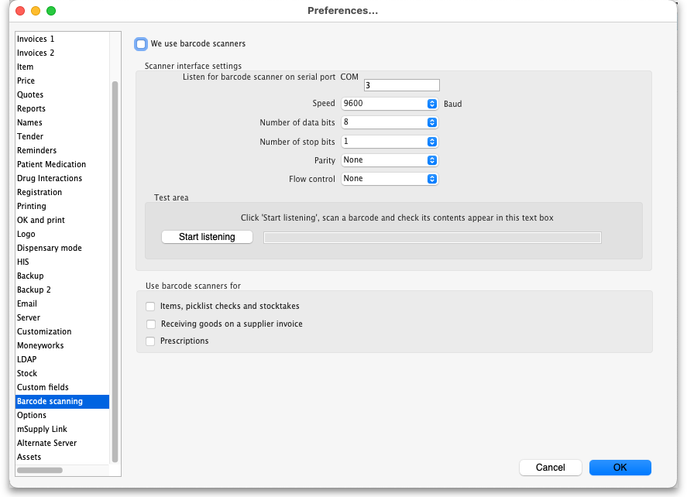
We use barcode scanners: Check this if you will use barcode scanners with mSupply on this computer. When it is checked, mSupply will automatically try to connect to the scanner when it starts. You will get an error message if the port in the settings is closed (usually caused by the scanner not being connected or turned off). When this is checked, it also modifies the way certain things work in mSupply. For example, when checked, a new Barcode drop down list appears on the new line window of a supplier invoice and stocktakes work differently.

Scanner interface settings
Listen for barcode scanner on serial port drop down list: contains a list of all the serial ports available on the computer. Select the one the barcode scanner is connected to. Note, if the barcode scanner was previously connected to a port but it is now turned off or disconnected and the port is no longer available, the port will appear as “Disconnected port” in the list and will be selected by default.
Speed drop down list: the speed that data is communicated over the serial connection in Baud (900 to 230400).
Number of data bits drop down list: the number of data bits in a packet of information sent over the serial connection (5,6,7 or 8).
Number of stop bits drop down list: the number of stop bits in a packet of information sent over the serial connection (1, 1.5 or 2).
Parity drop down list: the type of parity used in the serial communication (Odd, Even or None).
Flow control drop down list: the type of flow control (None, RTS/CTS or Xon/Xoff).

Test area
Start listening button: When you have made your selections in the Scanner interface settings section, you can click this button to test whether the port settings are correct and mSupply can receive scanned output from the scanner. When you click it, mSupply attempts to open the selected port with the selected settings and listens to the scanner.
If you get an error message, that means the port you selected in the Listen for barcode scanner on serial port drop down list couldn't be opened. That will be because the barcode scanner isn't connected or turned on or the scanner driver isn't properly set up.
If you don't get an error message and the scan appears but it's garbled or doesn't match what the barcode contains then one or more of the settings below the Listen for barcode scanner on serial port drop down list are wrong. Refer to your scanner documentation to determine what the correct settings are (or configure you scanner to match the settings you've chosen).
If the port settings are all correct and communication with the scanner is good, the contents of the scan will be displayed correctly in the text box.
To change the settings, click on the Stop listening button (the button label toggles between “Start listening” and “Stop listening”), adjust the settings, and click on the button again before trying another scan.
When you are happy the scans are being read by mSupply, your setup of the scanner is complete.

Use barcode scanners for
This section is where you tell mSupply in which areas to use barcoding:
- Items, picklist checks and stocktakes checkbox: If this is checked, mSupply will use barcode scanners when stocktaking, picklist checking and when editing items. See the 15.04. Barcode scanning and stocktaking, 15.05. Barcode scanning and pick list checking and 15.02. Adding barcodes to items pages for details.
- Receiving goods on a supplier invoice checkbox: If checked, mSupply will use barcode scanners when receiving goods at the supplier invoice stage. See the 15.03. Barcode scanning and receiving goods page for details.
- Prescriptions checkbox: If checked, barcode scanners can be used with prescriptions. See the 10.02. Prescription entry page for details.

Previous: 16.08. FrontlineSMS | | Next: 16.10. Options (standard reasons)

