Users
Only users who have been added to the mSupply user list can log in.

Adding a new user
- Choose File > Edit users
- Click the New button
- You will be shown the user window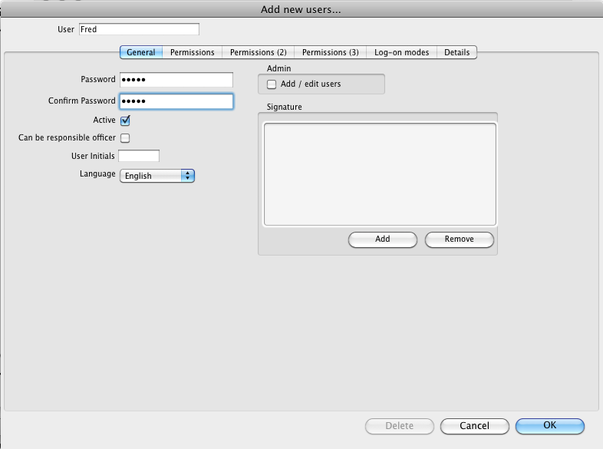
- Fill in:
  - The user name
  - assign a password
  - enter password again
  - Go to the permissions tabs and set up permissions (3 tabs)
  - Go to the Log-on modes tab and set up log-in modes
  - For a normal store user set up like this:
    - 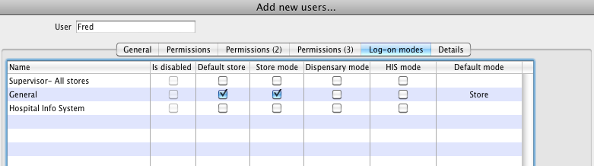
  - Click OK when you're done.
  - The user should now be able to log on.
  - After the user logs in, they may want to change their password by choosing File > Change password

