6.03. Purchase order categories
Sometimes it's really helpful to categorise your purchase orders for reporting purposes. To allow you to do this, mSupply allows you to create purchase order categories and then apply them to purchase orders as needed.

Viewing purchase order categories
Choose Supplier > Show purchase order categories… from the menus. You will be shown this window:
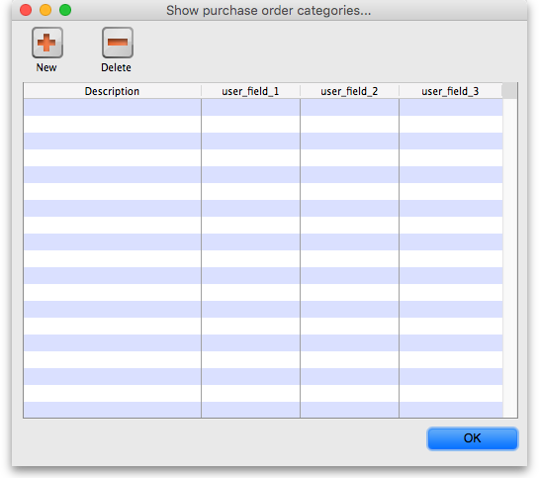
This shows a fill list of all the purchase order categories that you have at the moment. The user_field_1-3 columns show the values of the custom values given to each category, which can be used to further refine your reporting later.
Adding, deleting and editing purchase order categories are all done through this window.

Adding purchase order categories
Click on the New button in the window shown above to add a new category. This window will open:
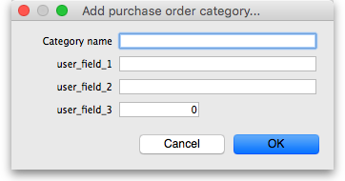
- Enter the following:
  - Category name: Description of the category. This is name by which the category will be known and selected throughout mSupply
  - user_field_1: Any alphanumeric value
  - user_field_2: Any alphanumeric value
  - user_field_3: Any numeric value
- Click on the OK button to save the new category
You will see the new category immediately added to the list of available purchase order categories.

Deleting a purchase order category
Select the category to delete in the list of purchase order categories and click on the Delete button. You will be asked to confirm the deletion.
You will only be able to delete a purchase order category if no purchase orders belong to it.

Editing an existing purchase order category
To edit a purchase order category simply double-click on it in the list. The same window as for adding a new purchase order category will open populated with the selected category's details. Simply edit the details as required and click on the OK button to save your changes.

Assigning categories to purchase orders
Assigning categories to purchase orders is really simple, as you'd expect! When editing or creating a purchase order, simply select the category the purchase order belongs to using the Category drop down list on the General tab:
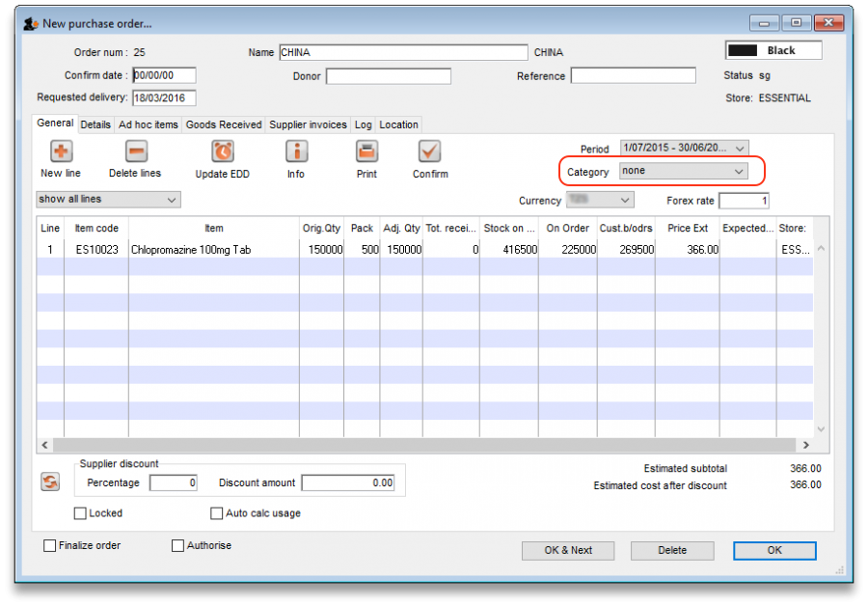
The drop down list will contain the descriptions of all the categories you have added.
Previous: 6.02. Managing purchase orders | | Next: 6.04. Ordering from one store to another

