13.05. Stocktake reports
Stocktake reports enable you to report over multiple stocktakes. If you want detail from a single stocktake, there are several options for reports you can run from within a stocktake, see the 4.17. Stocktakes page for details.
Choose Report > Stocktakes… from the menu. The report options window opens:
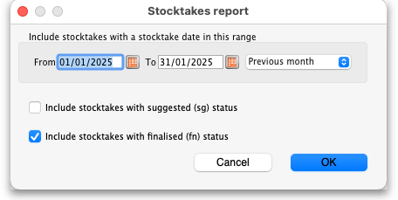
- From and To dates: Enter the range of dates of stocktake to include in the report. This range will be compared to the Stocktake date of a stocktake, not its created date. Enter the dates manually, by clicking on the calendar icons or selecting something from the quick range chooser drop down list on the right.
- Include stocktakes with suggested (sg) status: If this is checked then lines from stocktakes with suggested status will be included in the report.
- Include stocktakes with Finalised (fn) status: If this is checked then lines from stocktakes with finalised status will be included in the report.
When you have entered your various choices, click on the OK button to run the report. The report will be created and automatically opened in you spreadsheet application. It looks like this:
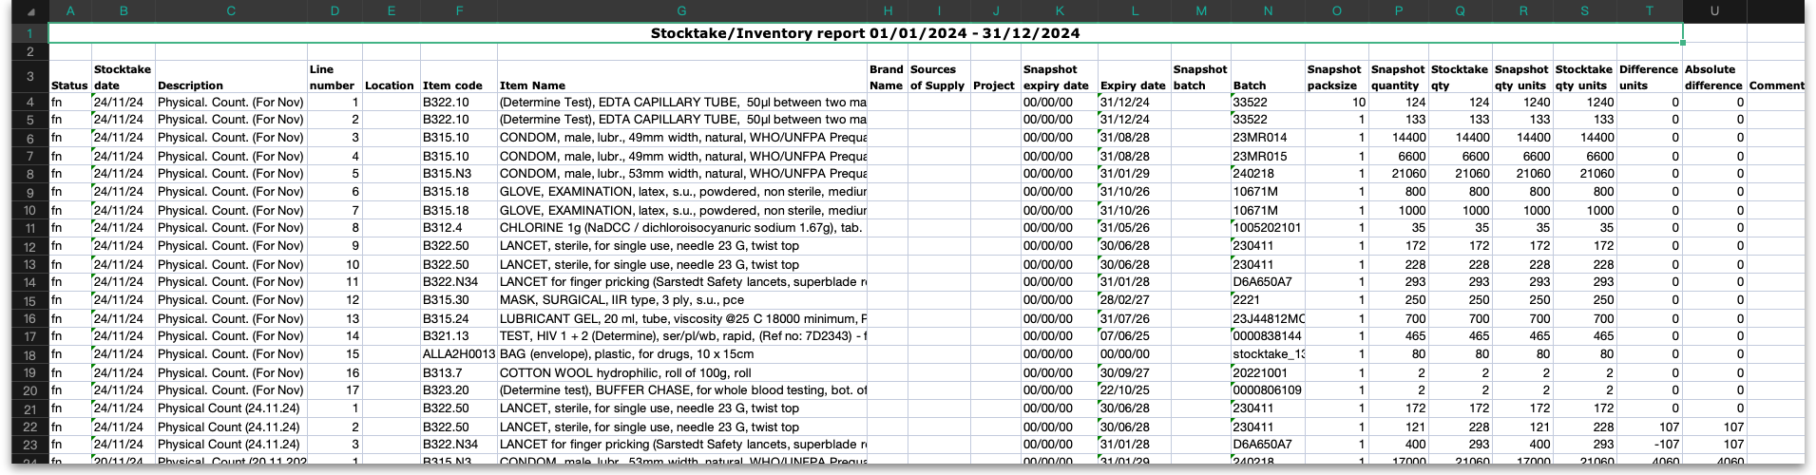
The report shows details of all the stocktake lines on stocktakes that match the report filters you selected above. The lines are grouped by stocktake and shown in line number order. What the columns contain:
- Status: The status of the stocktake this line came from.
- Stocktake date: The stocktske date of the stocktake this line came from.
- Line number: This stocktake line's line number.
- Location: The location of the stock in this stocktake line.
- Item code: The code of the item this line is for.
- Item name: The name of the item this line is for.
- Brand name, Sources of supply and Project: The values entered for custom stock fields (see the 16.01. General preferences page for details). Any custom stock fields that are turned on will appear here and the column headings will be the names the fields are given in the settings.
- Snapshot expiry date: The expiry date for this stocktake line when the stocktake was created. Will be “00/00/00” if the line was added after the stocktake was created.
- Expiry date: The expiry date for this stocktake line when the stocktake was finalised (also called the “counted expiry date”).
- Snapshot batch: The batch of this stocktake line when the stocktake was created. Will be empty if the stockline was added to the stocktake after creation.
- Batch: The batch of this stocktake line when the stocktake was finalised (also called the “counted batch”).
- Snapshot packsize: The packsize (number of units in a pack) for this stocktake line.
- Snapshot quantity: The number of packs of this stocktake line when the stocktake was created.
- Stocktake qty: The number of packs of this stocktake line when the stocktake was finalised (also called the “counted packs”).
- Snapshot qty units: The number of units of this stocktake line when the stocktake was created (= Snapshot packs x Snapshot quantity).
- Stocktake qty units: The number of units of this stocktake line when the stocktake was finalised (= Snapshot packs x Stocktake qty). Also called “counted units”.
- Difference units: Stocktake qty units minus Snapshot qty units (can be negative).
- Absolute difference: Difference units with any negative sign removed.
- Comment: The comment entered for this stocktake line.
- Reason: Only shown if reasons are being used (see the 16.10. Options (standard reasons) page for details) and there is a reason entered for one of the stocktake lines included in this report. The column shows the reason chosen for the difference between Snapshot quantity and Stocktake qty for this stocktake line.

Previous: 13.04. Purchasing reports | | Next: 13.06. Requisition reports

