9.02. Receiving goods back from a customer
It is important to be able to receive goods back from a customer without it being counted as goods coming from a supplier. If your customer issues the goods to you on a Customer Invoice, and you then receive it through a Supplier Invoice, then those goods will be counted as part of your store's 'supply' from suppliers, which is not correct. A Customer credit is the right way to receive goods back from a customer.
If you have accidentally confirmed (and finalised) a Customer Invoice, then you should be able to cancel it to bring the stock back in, rather than creating a customer credit.
If one of your customers wishes to return goods to you, you should receive them back into your store using a customer credit transaction.
You can create a customer credit manually or it can be created automatically in your store if your customer is a store in mSupply and they create a supplier credit to return the goods to you - see the 9.01. Return goods to a supplier page for details about that.
Customer credits created automatically will have the status new (nw) and placed on hold so that they do not affect stock in your store. When the goods physically arrive at your store, you can check them over, verify quantities, batches, condition, etc., make any necessary adjustments to the customer credit before taking it off hold and receiving the returned goods in to stock in mSupply.

Viewing and editing customer credits
Choose Customer > Show invoices… from the menu or click on the Show customer invoices icon on the Customers tab of the navigator:
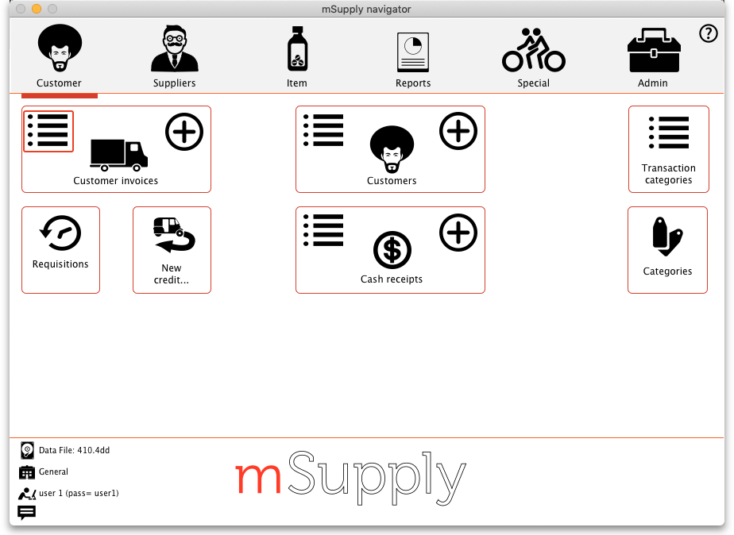
This will show you the search filter window:
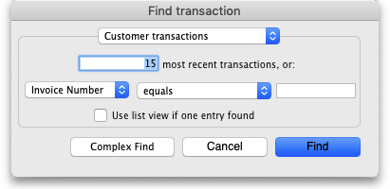
Note that the drop down list at the top is set to Customer transactions. Edit the other filter selections as required (leave the top drop down list as it is) and click on the OK button to see a list of all customer transactions (invoices, credits etc.). The customer credits are the ones with “cc” in the Type column:
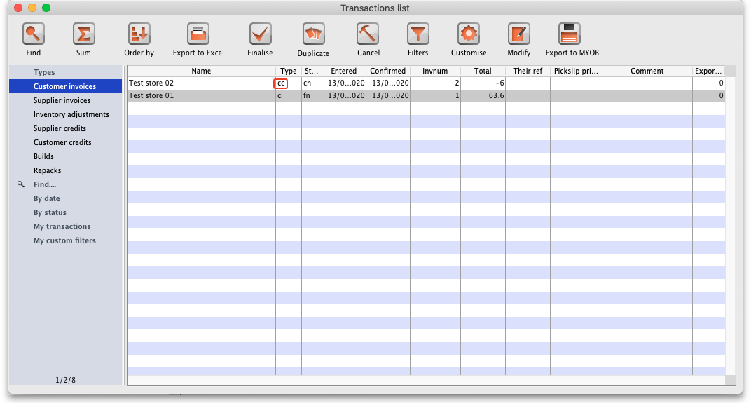
Double click on any transaction in the list to view or edit it.

Manually creating customer credits
Choose Customer > New credit… from the menu bar or click on the New credit… icon on the Customer tab of the navigator to open this window:
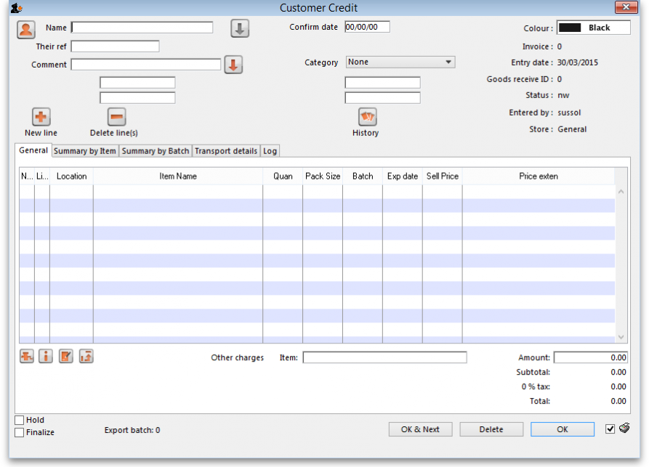
Enter the name of the customer you are receiving the goods from in the Name field by typing the first few characters of the name and pressing the Tab key on the keyboard to select it.
If the customer is on hold you will be warned and asked if you wish to proceed with receiving the goods back from them.
Enter a reference and comment in the Their ref and Comment fields if required.
Now you need to add the goods that are begin returned to you. There are two ways of doing this:
1) Click on the New line button to add a line to the credit and this window will open:
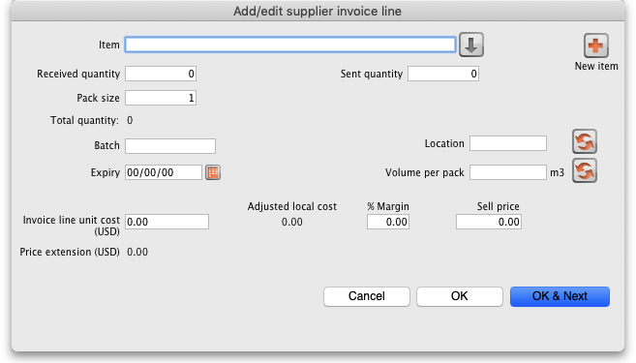
Here you can enter the details of the first batch you are receiving. This is exactly the same as filling out the details for a supplier invoice line. Enter the name of the item first by typing the first few characters of the name or code then press the Tab key on the keyboard to select the right item. Now enter the rest of the details as required, to match the stock being returned.
Note that on the customer credit you should enter items with zero margin. This is because mSupply uses the cost price entered to calculate the amount to credit the customer, so you must enter the amount you charged them as the cost price for each line. Presumably you want to sell the item again for the same price you sold it originally, hence the cost and selling price should be the same.
When you have finished entering this line's details, click on the OK button if you're finished or the OK & Next button to add another line. When you've finished adding lines, click on the OK or Cancel button and you'll be taken back top the customer credit window, now showing the lines added.
2) Click on the History button. This window will open:
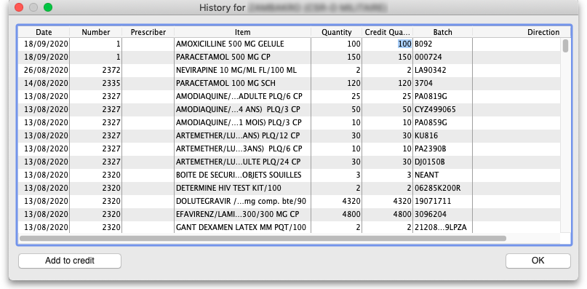
The list shows all the items that have been issued to this customer in date order, most recent at the top. Click on the line you wish to be returned and click on the Add to credit button. If you do not want to return the whole of the line then click on the Credit quantity cell and enter the quantity to be returned. Click on the Add to credit button to add the entered quantity of that line to the credit.
You can only add a single line to the credit at a time. If you wish to close the window without adding anything to the credit, click on the OK button.
Repeat the process as many times as you wish until you have added all the items to be returned.
If the Limit patient and customer credits to previously prescribed items preference is turned on (see 15.03. Invoice preferences) then the History button is the only way you can add items to the customer credit (the New line button will be disabled).
Whichever way you add the lines to the credit, when you have finished doing so, click on the OK button to save the customer credit. This will automatically confirm it and put the items on it into your stock in mSupply.
There is no need to enter negative values for quantities or prices in mSupply. Even when you are entering returned goods from customers, or returning goods to suppliers, enter positive values. mSupply automatically converts the amounts to negative values as required to keep all the figures in correct balance.

Creating a customer credit from a finalised customer invoice
If a user has the Return stock from customer invoices permission set (see the 25.15. Managing users section for details), then, when they open a finalised customer invoice, a Return selected lines button will be displayed:
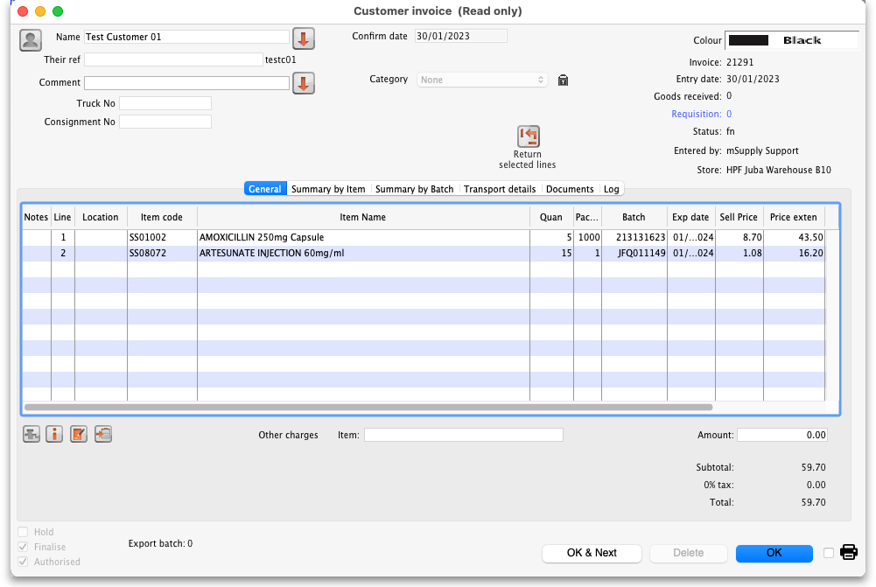
Select the lines you wish to return by clicking on them in the table (the usual Shift and Ctrl/Cmd+click and Ctrl/Cmd+A combinations are available) then click on the button to see the window where you enter the number of packs you wish to return:
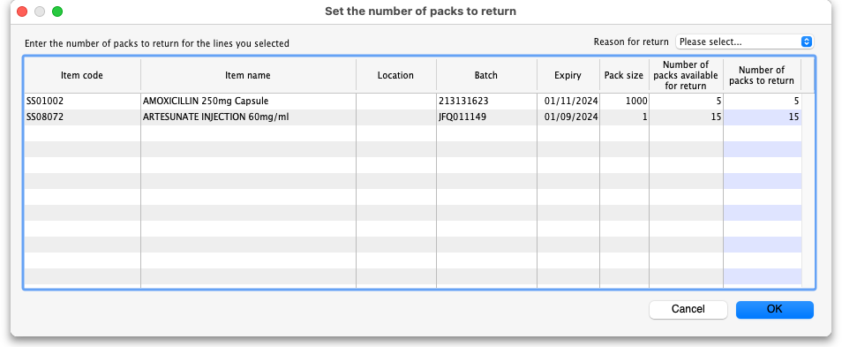
Each line you selected on the customer invoice is shown in the table. In the Number of packs to return column, enter the number of packs you wish to return for each line (this number must be equal to or less than the number of packs for this line on the customer invoice). If you wish, select the reason for return in the drop down list in the top right hand corner of the window. This drop down list is populated with your customer credit transaction categories (see the 26.06. Transaction categories page for details on this).
When you're done, click on the OK button. You are asked for confirmation and then a finalised customer credit (with the transaction category you selected in the Reason for return drop down list) is created for you, which you can view as described in Viewing and editing customer credits.
It makes no difference whether this customer invoice is a stock transfer or a normnal customer invoice: a finalised customer credit is created in either case.
Previous: 9.01. Return goods to a supplier | | Next: 10. Dispensing goods

