3.07. Viewing Names in Google Maps
If you know the exact geographical location of the supplier or customer, the Lat (latitude) and Long (longitude) fields can be completed in their Photo tab.
You should use the following conventions when entering the exact geographic location for a supplier or customer:
- Use decimal degrees (not degrees, minutes and seconds)
- In the Lat field, locations south of the equator are entered as negative - i.e. the number is preceded by a '-' sign
- In the Long field, locations west of the prime meridian are entered as negative - i.e. the number is preceded by a '-' sign
You can use Google Maps to find the exact geographical location. Find the desired location on Google Maps and place the cursor on it. Right-click and select What's here from the drop-down list. Google Maps will display the geographical coordinates (the first number is latitude and the second number is longitude). These should be noted and copied to the Lat and Long fields in mSupply.
In our example, the location of the imaginary Acme Pharmaceuticals is on Chetrapati in Kathmandu. Click on the Google Maps button to display a map of the vicinity. The precise location is pinpointed by a green arrow.
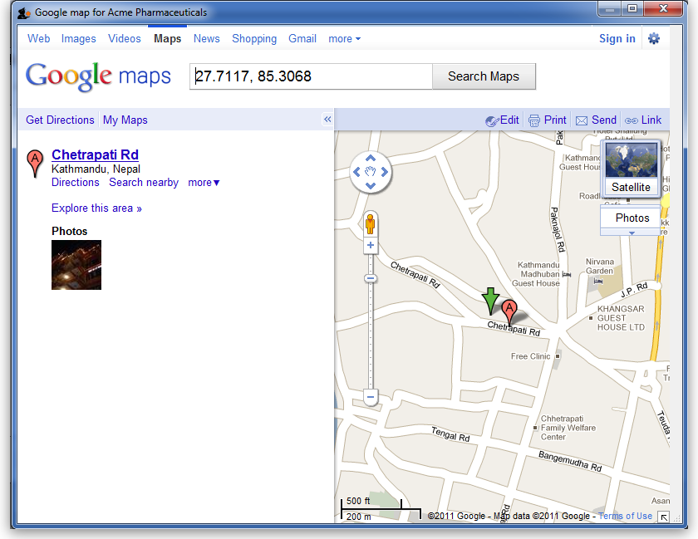

Previous: 3.06. Customers and suppliers | | Next: 3.08. Enter incoming goods (supplier invoices)

