3.03. Opening the example data file
You will have two icons on your desktop - double-click the mSupply icon.
If you are opening mSupply® for the first time, the program should automatically open the example data file.
The full path to the data file is displayed, along with other useful information by choosing Menu >Help>About mSupply:
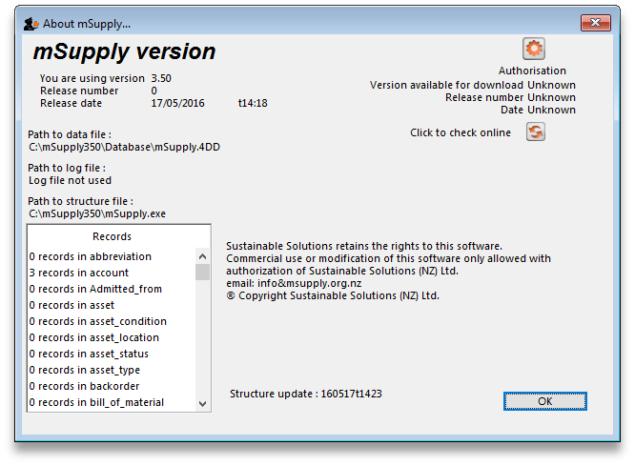
If you have already been using mSupply® and have another data file open, but would like to open the example data file for use with this tutorial, then you can use the mSupply® menu File > Open data file… to open the example data file. In Windows, by default the example data folder is stored inside c:/mSupply/database/; navigate to the location and open the data file.
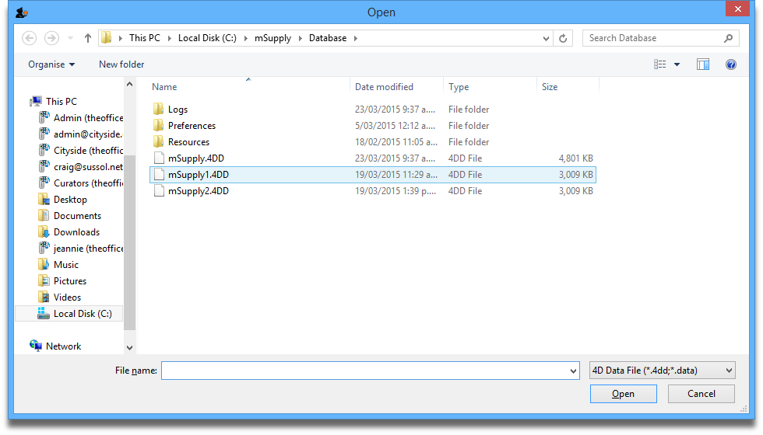
If you have chosen a different location from the one suggested by the installer, the example folder will be in your chosen location.
A password entry window is presented as mSupply® opens up a data file. The message panel informs the user that the example data base is in use.
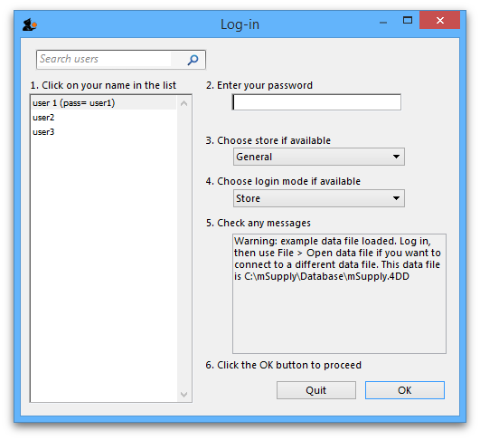
The “User 1” (pass= “user1”) entry should be highlighted, but if it is not, it should be selected. Enter “user1” (without the quotes) at 2.Enter your password.
The Choose store …. . drop-down list will display General, and the Choose login mode … drop-down list will display Store - these should not be changed. Click the OK button. After you have logged on, the Navigator screen appears:

Previous: 3.1. Logging in | | Next: 3.3. Working with lists

